# ICT & Infra S3 Supporting Services and Monitoring week 4 (ver 2023)

|  |  |
| --- | --- |
| Class: |  |
| Student number: | Himar Marichal Delgado |
| Student name: |  |

## Introduction

### Assignment 1. RDS Resilience testing on AWS

### Difficulty: ★★★☆☆.

AWS documentation states that failover usually lasts between 60-120 seconds. The purpose of this assignment is to check if these estimations are correct, at least for MySQL databases.

1. Spin up a MySQL RDS instance, **with Muti-AZ enabled**
   1. Choose Dev/Test option and a burstable class db.t3.micro
   2. Set public access to Yes
   3. In “Additional configuration” specify an Initial database name to be created directly after instance is created. Name it as you wish, for instance, week8db.
2. Use [SQL script](https://portal.fhict.nl/Studentenplein/LMC/2021nj/Infrastructure/S3-CB/Monitoring_SupportingServices/transactions.sql) to create a table in the database week8db. If you used different for the database, you’ll need to change it in the script. This script you can run from MySQL Workbench, or any other tool.
3. For this part you will need a running Linux environment. It may require mysql command line client installation. Amend this [script](https://portal.fhict.nl/Studentenplein/LMC/2021nj/Infrastructure/S3-CB/Monitoring_SupportingServices/testfailover.sh) so that it can connect to your database. Alternatively, you can rewrite the script for PowerShell.
4. Execute the script . It will generate the output similar to the following:

1. Reboot your RDS instance, don’t forget to **check the failover option**!
2. Observe the output of the script. Terminate it once the connection is restored, make a screenshot and add it to your report. **How much time did the failover take in your case?**
3. In CloudTrail find the related events and try explaining them. Attach the screenshot to the report**. How do we know this failover was caused by the user initiated reboot?**
4. **Optional.** Create a dashboard in CloudWatch to monitor read and write IOPS for your database. Amend the following [script](https://portal.fhict.nl/Studentenplein/LMC/2021nj/Infrastructure/S3-CB/Monitoring_SupportingServices/testwrite.sh) to match your configuration and execute it. How the workload is reflected in your dashboard? Do you have enough IOPS to sustain this load? Provide a couple of screenshots with the explanation what was going on at the database level.

|  |
| --- |
| *Solution:* |

This is the first time I connected to the RDS using command line.*After I connected to the RDS I used the week8db database. Inside this database I created a Table called transactions. 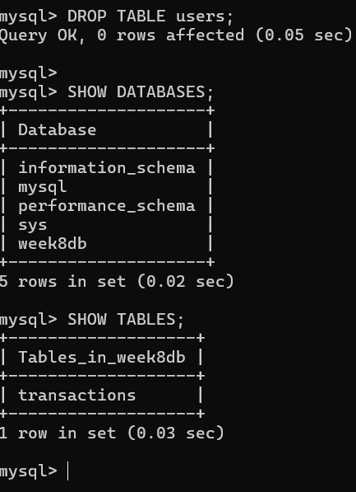

I then used the failover.sh file. I input the credentials required by the code. I covered the password for obvious reasons.



This was the Output after I started running it.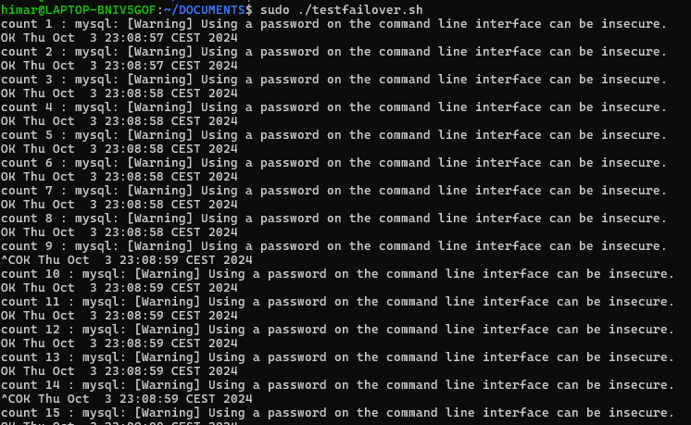

Then while this script was running I rebooted my RDS with Failover.

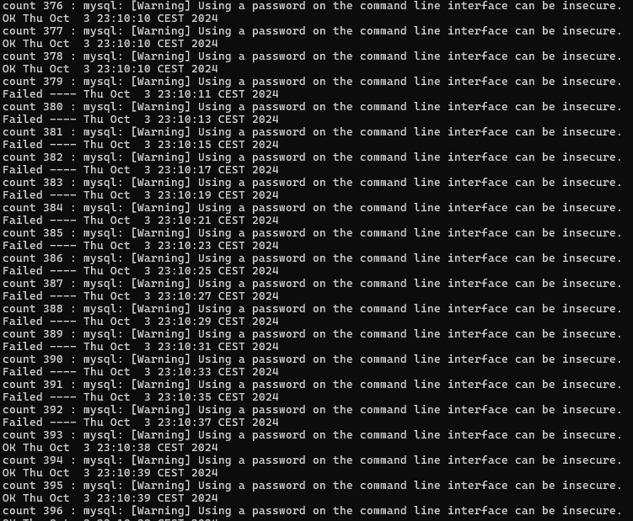

As you can see from count 379 till count 392. A total of 14 counts, which is a time of:

* Current Time Count(392)-Current Time Count (379)=23:10:11-23:10:37=26 seconds.

It took a time of 26 seconds to Reboot.

This was what I found in CloudTrail. We ca

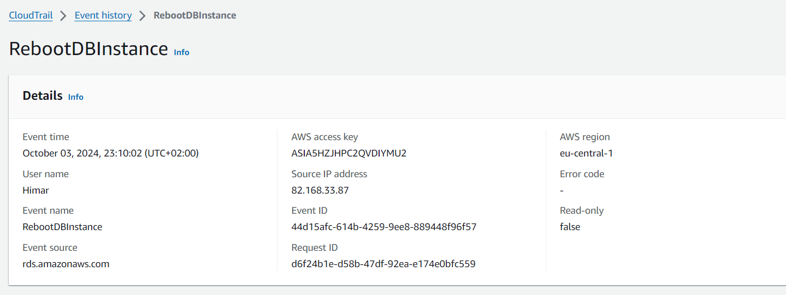

This event was detected at 23:10:02. It took the script an amount of 10 seconds to detect a Reboot was being made. If you go to count 379 you can see that this event and that count have similar times.